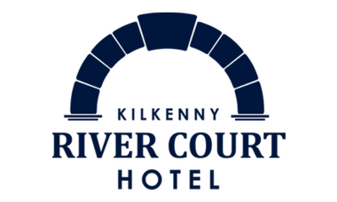

RIVERVIEW BAR MORNING MENU 11-12.30pm

Fruit Scone - cream, preserves, Irish butter € 4.50
Plain scone - cream, preserve, Irish butter € 4.50

TEA/COFFEE
Americano €3.20
Cappuccino (mk) €4.20
Flat White (mk) €4.20
Latte (mk) €4.20
Espresso €3.20
Hot Chocolate (mk) €3.20
Mocha (mk) €4.20
Traditional Tea €3.20
Speciality Tea €3.20
(camomile, green, peppermint, earl grey)

SPECIALITY COFFEES & AFTER DINNER DRINKS
Irish Coffee (mk) €9.50
Calypso Coffee (mk) €9.50
Baileys Coffee (mk) €9.50
Liqueur Coffee (mk) €9.50
Crème de Menthe €6
Sambuca €9
Hennessy VS SP €6
Baileys (mk) €5
Winter’s Tale Sherry €6
Sandeman 3-star Port €6
Harvey’s Bristol Cream €6

ALLERGEN INDEX
G = Gluten, C = Crustaceans, E = Eggs, F = Fish, M = Molluscs,
S = Soyabeans, SP = Sulphites, P = Peanuts, MK = Milk, CY = Celery
MD = Mustard, SS = Sesame Seeds, L = Lupin, N = Nuts
© = Coeliac option available

Gluten free options available.
Please ask Yor server.
RIVERVIEW BAR MENU
12.30pm – 9pm (8.30pm Sunday)

TO START

FRESH HOMEMADE SOUP (V) €7.50
homemade brown bread, Irish butter (g)(sp)(mk)(cy)©

SEAFOOD CHOWDER €9
wild Atlantic fish, brunoise vegetables, fish velouté,
fresh dill (c)(f)(m)(mk)(cy)(g)

RIVERVIEW CHICKEN WINGS €10
crisp fried chicken wings, BBQ sauce
blue cheese dip, stem celery (mk)(e)(cy)©

ST TOLA GOATS CHEESE TARTLET €9.50
red onion marmalade, tomato concasse, wild rocket,
balsamic reduction (mk)(e)©

THAI STYLE FISH CAKE €10
ginger, soy, chilli and spring onion dipping sauce (mk)(f)(s)(sp)(g)

LIGHT BITES

RIVERCOURT CAESAR SALAD €15
cos lettuce, garlic croutons, bacon lardons, creamy Caesar dressing,
cajun spiced chicken, parmesan shavings (g)(e)(f)(sp)(mk)©

SUPERFOOD SALAD €15
quinoa, peach, strawberries, toasted cashew nuts,
fresh baby leaves, citrus dressing (n)

SANDWICHES

RIVERVIEW TOASTED SPECIAL €9.50
honey roast ham, mature red cheddar, vine tomato
red onion, chunky chips (g)(mk)(md)©

CLASSIC CAESAR WRAP €9.50
baby gem, garlic croutons, lardons, parmesan shavings,
cajun spiced chicken (g)(e)(f)(sp)(mk)

OPEN ATLANTIC SHRIMP €9.50
cold water atlantic shrimp, cocktail sauce, homemade brown
soda bread (g)(e)©

MAINS

QUIGLEY BUTCHERS PRIME ANGUS 7oz BEEF BURGER €18
brioche bun, smoked bacon, Dubliner cheese, beef tomato,
tomato and onion relish, crispy fried onion ring,
twice cooked chunky chips (g)(mk)(md)(e)(sp)

THAI RED CHICKEN CURRY €17
shallow fried chicken, stir fry oriental vegetables,
jasmine infused rice (f)(md)(ss)(mk)©
VEGAN - with tofu €17

CAJUN FRIED CHICKEN FILLET BURGER €18
baby gem lettuce, Cajun mayo, beef tomato, red onion,
Monterey jack cheese, crispy onion ring, twice fried chunky chips (g)(mk)(md)(e)(sp)©

QUIGLEY BUTCHERS ANGUS STRIPLOIN STEAK €29.50
10oz certified Angus, caramelised onions, portobello mushroom,
twice cooked chunky chips or creamy mash,
brandy cream pepper sauce or garlic butter (mk)(sp)(md)(cy)©

FISH & CHIPS €18
crispy beer batter, traditional mushy peas,
house tartare sauce, twice cooked chunky chips (f)(g)(mk)(e)(sp)

FALAFELL BURGER (v) €17
beetroot bun, pickle, beef tomato, truffle aioli, sweet potato fries (g)

SEE BLACKBOARD FOR SPECIALS

SIDES/DIPS
Twice cooked chips €4.20
Buttery Mash €4.20
Onion Rings €4.20
Seasonal Vegetables €4.20
Green Salad €4.20
Sweet Potato Fries €4.20
Cajun Mayo €1
Garlic Mayo €1
Red Onion Marmalade €1

ALLERGEN INDEX
G = Gluten, C = Crustaceans, E = Eggs, F = Fish, M = Molluscs,
S = Soyabeans, SP = Sulphites, P = Peanuts, MK = Milk, CY = Celery
MD = Mustard, SS = Sesame Seeds, L = Lupin, N = Nuts © = Coeliac option available

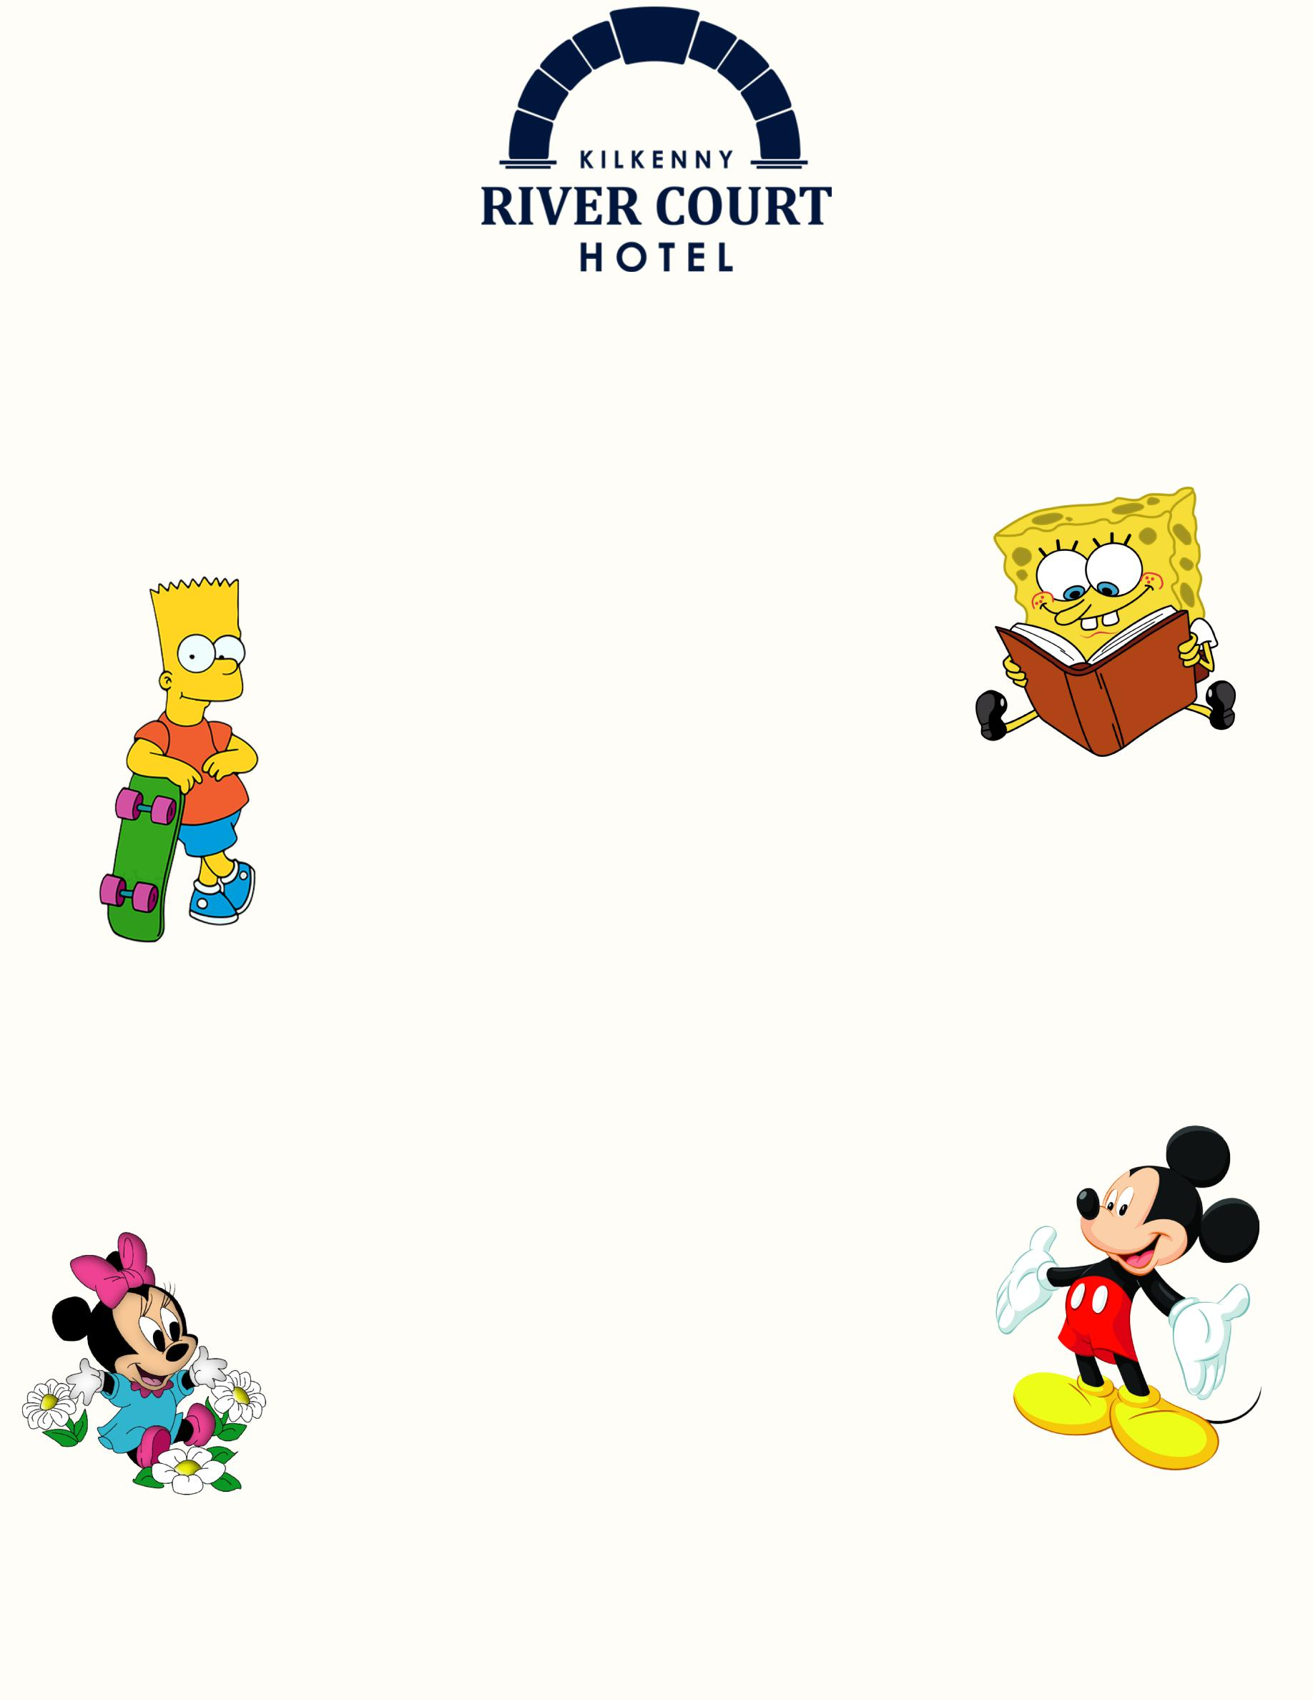

KIDS MENU

TO START

Soup of the Day(g) €4.20
Caesar Salad(g)(e) €4.20

THE MAIN BITES

Penne Pasta with Tomato Sauce &
Parmesan Cheese (g)(mk) €8
Bangers, Mash & Gravy (g)(mk)(md)(cy) €8
Chicken Goujons & Chips (g)(e)(mk) €8

FROM THE SWEET TOOTH FAIRY

Selection of Ice Cream(mk) €4.20
Chocolate Brownie(mk)(e)(g) €4.20
Fresh Fruit Salad €4.20

Gluten free options available.
Please ask Your server.

